**Gesture Based Tool for Sterile Browsing of**  **Radiology Images**

**Team ID:PNT2022TMID24103.**

**Submitted by:MIDHUN.M , MANOJ.S ,DURGA MAGESH , VISHNU VARDHAN.**

**1.INTRODUCTION**

# 1.1 Overview

In this project we use gestures to browse radiology images. Gestures refer to non-verbal form of communication.

A major challenge involved in this process is to provide doctors with efficient, intuitive, accurate and safe means of interaction without affecting the quality of their work. Keyboards and pointing devices, such as a mouse, are today's common method of human—computer interaction. However, the use of computer keyboards and mouse by doctors and nurses in intensive care units (ICUs) is a common method for spreading infections.

Humans can recognize body and sign language easily. This is possible due to the combination of vision and synaptic interactions that were formed along brain development.

In order to replicate this skill in computers, some problems need to be solved: how to separate objects of interest in images and which image capture technology and classification technique are more appropriate, among others. In this project Gesture based Desktop automation, First the model is trained pre trained on the images of different hand gestures, such as a showing numbers with fingers as 1,2,3,4. This model uses the integrated webcam to capture the video frame. The image of the gesture captured in the video frame is compared with the Pre-trained model and the gesture is identified. If the gesture predicts is 0 - then images is converted into rectangle, 1 - image is Resized , 2 - image is rotated, 3 - image is blurred.

# 1.2 PURPOSE

It is used to browse through the images obtained using radiology using hand gestures rather than using mouse,keyboard,etc thereby maintaining sterility.

# 2.LITERATURE SURVEY

2.1 A Gesture-based Tool for Sterile Browsing of Radiology Images - research paper by national library of medicine

The hand gesture control system “*Gestix*” developed by the authors helped the doctor to remain in place during the entire operation, without any need to move to the main control wall since all the commands were performed using hand gestures.The sterile gesture interface consists of a Canon VC-C4 camera, whose pan/tilt/zoom can be initially set using an infrared (IR) remote.

This camera is placed just over a large flat screen monitor .

Additionally, an Intel Pentium IV, (600MHz, OS: Windows XP) with a Matrox Standard II video-capturing device is used.

The “*Gibson*” image browser is a 3D visualization medical tool that enables examination of images, such as: MRIs, CT scans and X-rays. The images are arranged over a multiple layer 3D cylinder. The image of interest is found through rotating the cylinder in the four cardinal directions. To interface the gesture recognition routines with the “*Gibson*” system, information such as the centroid of the hand, its size, and orientation are used to enable screen operations in the “*Gibson*” graphical user interface.

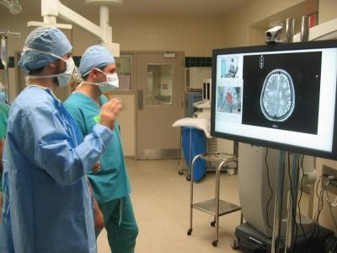

Fig 2. Radiology image browsing using hand gesture in hospital

# 3.THEORITICAL ANALYSIS

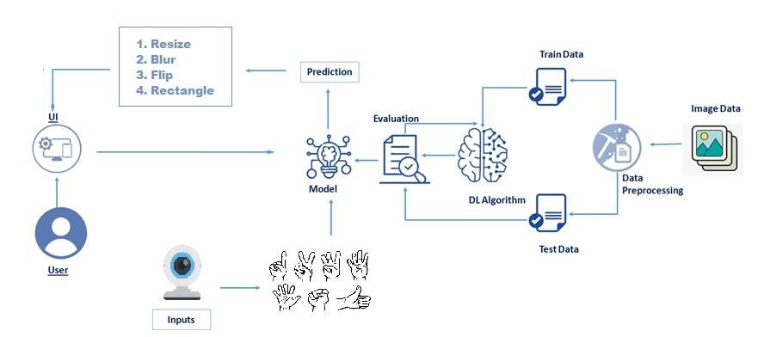

Fig 3. Architecture of Gesture Based Tool for Sterile Browsing of Radiology Images

# 4.EXPERIMENTAL INVESTIGATIONS

We found that many hospitals rely on mouse and keyboard to browse the images that are obtained during different surgeries, scans, etc. This can contaminate the environment with various infections thus compromising the sterility.

Various technologies have been developed to overcome this issue and one such technology was called ‘Gestix’.

This hand gesture system for MRI manipulation in an EMR image database called “*Gestix*” was tested during a brain biopsy surgery. This system is a real-time hand-tracking recognition technique based on color and motion fusion. In an in vivo experiment, this type of interface prevented the surgeon's focus shift and change of location while achieving rapid intuitive interaction with an EMR image database. In addition to allowing sterile interaction with EMRs, the “*Gestix*” hand gesture interface provides:

1. ease of use—the system allows the surgeon to use his/her hands, their natural work tool;
2. rapid reaction—nonverbal instructions by hand gesture commands are intuitive and fast
3. an unencumbered interface—the proposed system does not require the surgeon to attach a microphone, use head-mounted (body-contact) sensing devices or to use foot pedals
4. distance control—the hand gestures can be performed up to 5 meters from the camera and still be recognized accurately.

# 5.FLOWCHART

* User interacts with the UI (User Interface) to upload the image as input.

* Depending on the different gesture inputs different operations are applied to the input image.

* Once model analyses the gesture, the prediction with operation applied on image is showcased on the UI. To accomplish this, we have to complete all the activities and tasks listed below:

* Data Collection.
  1. Collect the dataset or Create the dataset

* Data Pre processing
  1. Import the ImageDataGenerator library

○ Configure ImageDataGenerator class

○ Apply ImageDataGenerator functionality to Trainset and Testset

* Model Building
  1. Import the model building Libraries

○ Initializing the model

○ Adding Input Layer

○ Adding Hidden Layer

○ Adding Output Layer

○ Configure the Learning Process

○ Training and testing the model

○ Save the Model

* Application Building
  1. Create an HTML file

○ Build Python Code Following software, concepts and packages are used in this project

* Anaconda navigator

* Python packages:
  1. open anaconda prompt as administrator

○ Type “pip install TensorFlow” (make sure you are working on python 64 bit)

○ Type “pip install opencv-python”

○ Type “pip install flask”

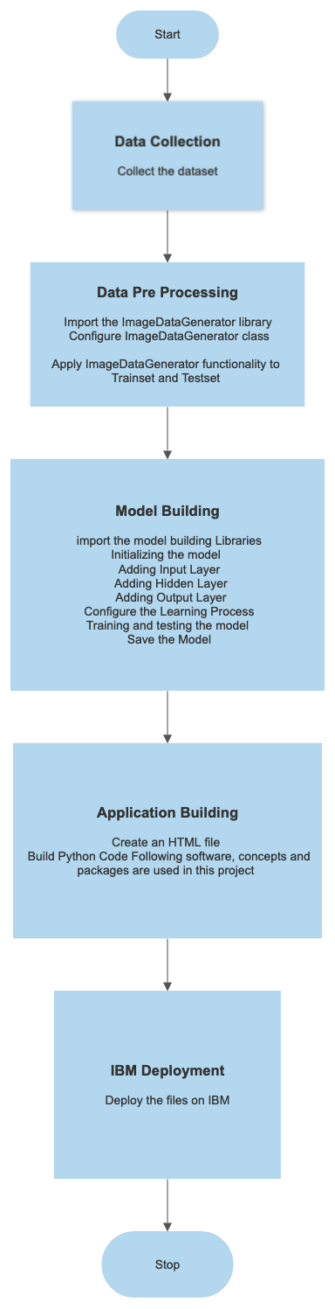

# 6.RESULT

Final findings (Output) of the project along with screenshots.

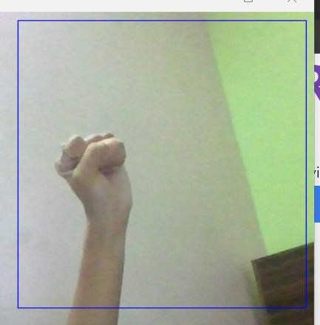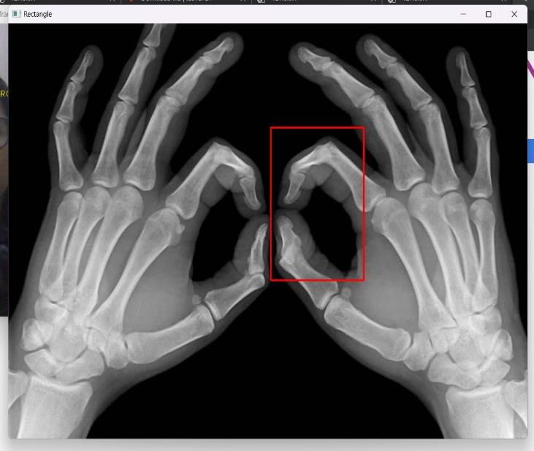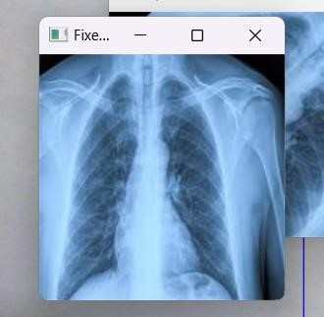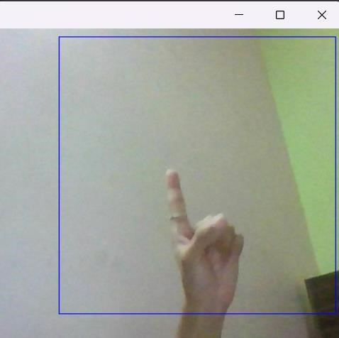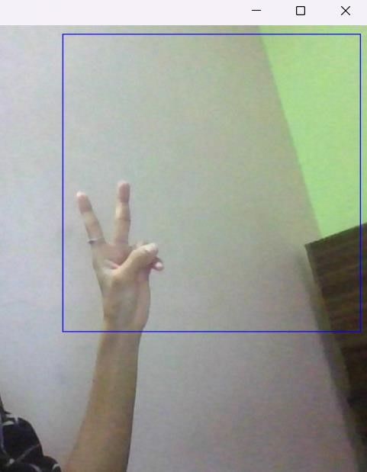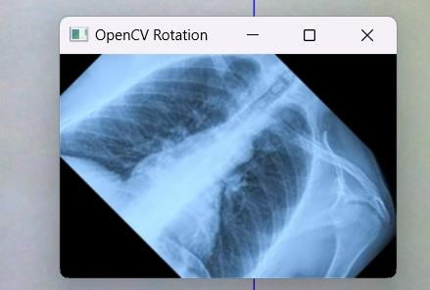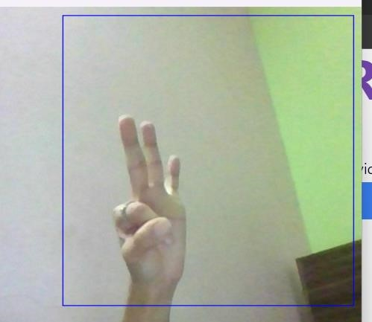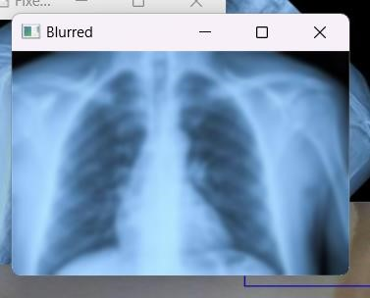

Through this project we found that we can maintain the sterility of an operation theater, etc by using hand based gesture tools to browse the images obtained.

# 7.ADVANTAGES & DISADVANTAGES

**Advantages:**

* Majoradvantage of this tool is that it helps to maintain the sterility of the environment.
* It is also easy to use and is quicker than the existing methods to browse images.
* It can also be performed even if the surgeon is a bit far away from the system, this helps to save time.
* The tool does not need the person using it to have an apparatus or any devices on them to use it. They can simply move their hands to browse through the images.

**Disadvantages:**

* The tool can be quite expensive as it requires cameras and other expensive devices to capture images and process it.

# 8.APPLICATIONS

* This hand based gesture tool developed can be mainly used in the medical industry to browse images without compromising the sterility.
* However it can also be used in different industries while presenting certain ideas, during meetings, and can be used by teachers while teaching.

# 9.CONCLUSION

In this project we developed a tool which recognises hand gestures and enables doctors to browse through radiology images using these gestures. This enables doctors and surgeons to maintain the sterility as they would not have to touch any mouse or keyboard to go through the images.

This tool is also easy to use and is quicker than the regular method of using mouse/keyboard.

It can be used regardless of the users location since they don’t have to be in contact with any device.

It also does not require the user to have any device on them to use it.

Further this technology can be extended to other industries like it can be used by presenters, by teachers for show images in the classroom, etc.

# 10.FUTURE SCOPE

* The tool can be made quicker by increasing the recognition speed.
* More number of gestures can be added thereby increasing this tool’s functionality and useability for different purposes.
* Tracking of both hands can be added to increase the set of commands. Voice commands can also be added to further increase the functionality.

# 11.REFERENCE

1. Qing Chen Nicolas, D. Georganas, and Emil M. Petriu "Hand Gesture Recognition Using Haar-Like

Features And A Stochastic Context-Free Grammar" IEEE ,Vol. 57, No. 8, August 2008

1. Anupam Agrawal, Rohit Raj and Shubha Porwal "Vision-based Multimodal HumanComputer

Interaction using Hand and Head Gestures" IEEE Conference on Information and Communication

Technologies ICT 2013

3.Kenji Oka and Yoichi Sato "Real-Time Fingertip Tracking and Gesture Recognition" IEEE proceeding on Computer Graphics and Applications Nov/Dec 2002

4. S. Ioffe and C. Szegedy, “Batch normalization: Accelerating deep network training by reducing internal covariate shift,” in International Conference on Machine Learning, 2015, pp. 448–456.

5.Juan Wachs, Helman Stern, Yael Edan, Michael Gillam, Jon Handler, Craig Feied, Mark Smith

6.Professor. Juan P. Wachs,

7.Professor. Benjamin Fritsch

# 11.Appendix

source code

[IBM-Project-51973-1660987548/Project Report (1).pdf at main · IBM-EPBL/IBM-Project-51973-1660987548 (github.com)](https://github.com/IBM-EPBL/IBM-Project-51973-1660987548)